ISI Roses
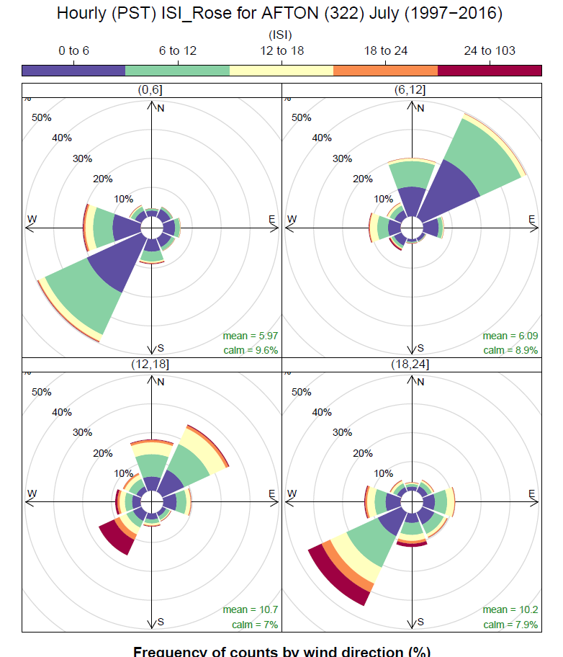

The Initial Spread Index (ISI) roses are completed for each active weather station in the BC Wildfire Service weather station network. If the station has less than 5 years of data it was omitted from the analysis. Environment Canada stations were also not included in this analysis.
The hourly roses were completed by months (April to October) for a total of seven pages for each station. The daily period was broken into four time periods 000 – 600 hrs (0, 6), 600 -1200 hrs (6, 12), 1200 -1800 hrs (12, 18) and 1800 -2400 hrs (18, 24).
Each rose shows the frequency of counts by wind direction with the frequency of the ISI values during that time period. The upper limits of the ISI is based on the highest recorded ISI for the station, in this case, the upper limit is 24-103 with 103 being the highest recorded ISI for this station.
These roses will have numerous uses within BCWS such as planning the placement of fuel treatments to help mitigate wildfire threat to values on the landscape or for use in a Fire analysis to show predominant spread direction for long term growth potential.

